Rod cutting problem: if the seller different size of rods, that selling for different prices, we want to maximize the profit made, by cutting up a rod of size n.
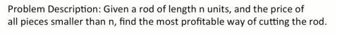

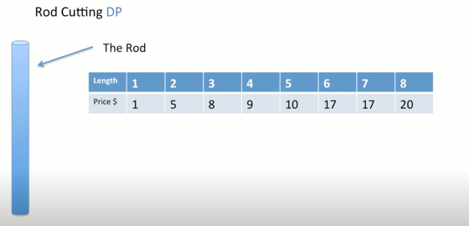

so if we have a retailer that want to maximize its profit by selling smaller pieces of rod.

Let say rode size:4

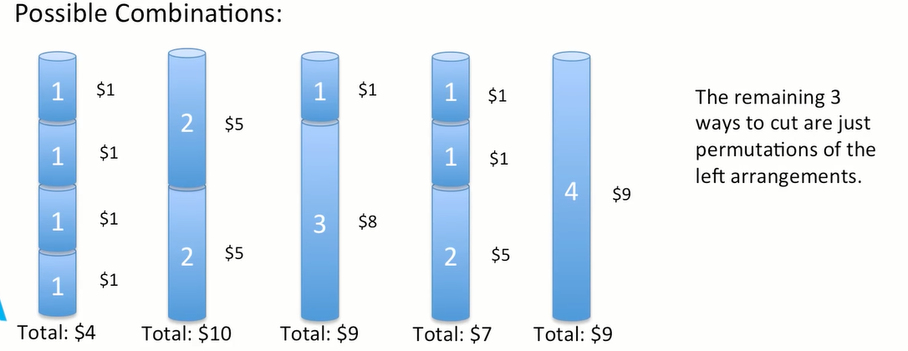
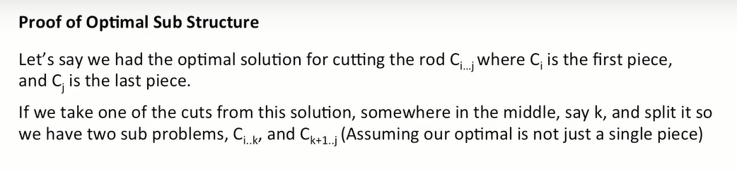

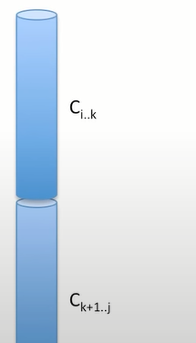
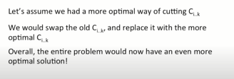

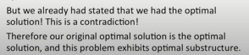

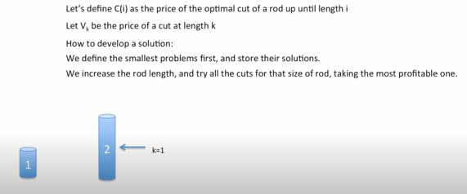
if we look at this one and we cut into two pieces of one, eachhave the value of 1 gives us 2.
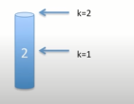
But if we cut at 2, the piece of size 2 will have a value of 5.

Our Recursive function is defined as
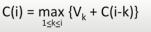

The technique we gonna use memoization.

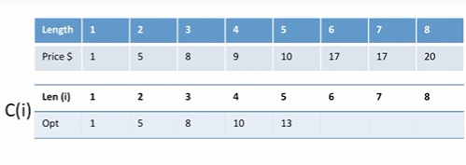
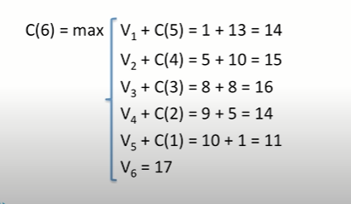

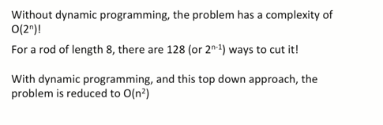

Edit distance ( Levenstien distance)

character ops
→ replace
→ delete
→ insert
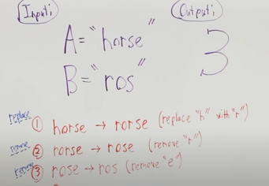

Substring operations and notation.
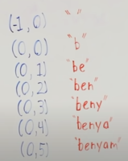

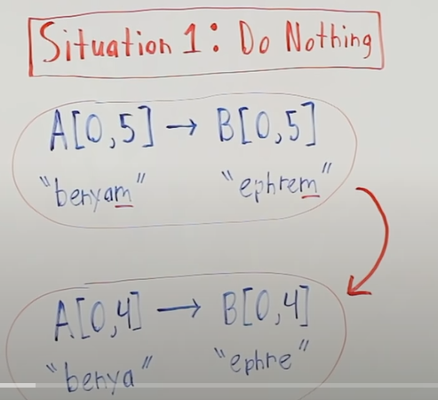

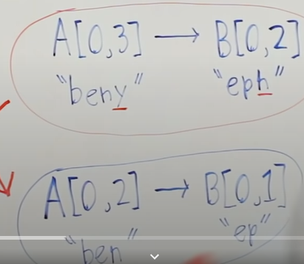
We can perform 3 operations
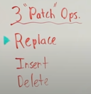

Replace
So what we gonna do, is we drop the ‘y’ and ‘h’ and
now ,all I want to do is turn ‘ben’ to ‘ep’
and after I have done that.
I replace y to h.

Insert
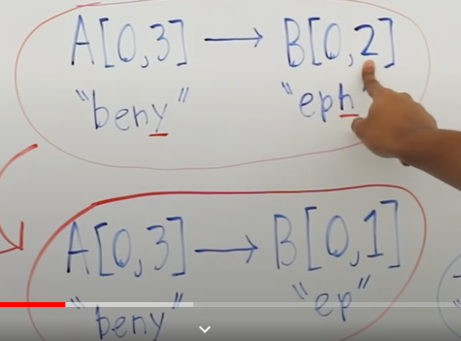
I am gonna subtract from the nth bound b.
I transform beny to ep.
After I have done that, I insert h at the end.

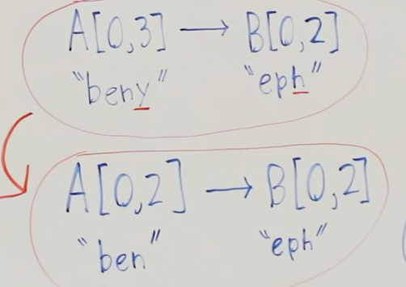
Deletion:

y is deleted.

Now
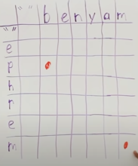
That dot means its a subproblem, each of this cells is a subproblem, we are interested in what is the edit distance between these 2 full strings, but we answer every subproblem leading up to that.
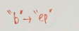

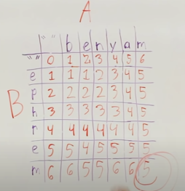
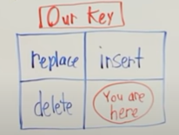

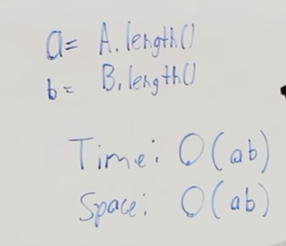

Here, how the subproblem pan out and how they build to global answer.

